Name ___________________________________________________ **Assessment Review Practice**



**Matter**



Defined as

:

____________________________

____

________

and takes up

___________________.



The

three states

:

Describe and illustrate

the the molecular level



Solid

:



Liquid

:



Gas

:



**Phase**

**Changes**



**Description of the phase changes:**

Melting Point = __________________ Point

_______________________ = Condensation

Deposition =

____________________________

**Volume – Three Methods to determining the Volume of an object or substance:**

|  |  |  |  |
| --- | --- | --- | --- |
|  | *Liquid* | *Irregular Shape Object* | *Cube* |
| Explanation or  Description of the  Method Used |  |  |  |
| Image/Illustration of the method. |  |  |  |

**Density -­‐ Definitions, Examples, and Practice Calculations:**

Definition -­‐ ___________________________________________________________________________

_____________________________________________________________________________________

Example:

Describe the densities of the liquids in the beaker to the right. Be

sure to discuss the amount of matter within the given volume of the

liquid. _______________________________________________________________________

Water, 1.0 g/mL _______________________________________________________________________________ _______________________________________________________________________________

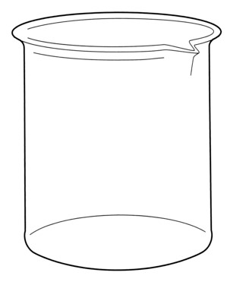

_______________________________________________________________________________

Practice Problems:

1. A graduated cylinder has a mass of 50 g when empty. When 30 mL of water is added, the graduated cylinder has a mass of 120 g. If a rock is added to the graduated cylinder, the water level rises to 75 mL and the total mass is now 250 g. What is the density of the rock?

1. A student performs an experiment with three unknown fluids and obtains the following measurements:

Fluid A: *m* = 2060 g, V = 2000 mL (color red)

Fluid B: *m* = 672 g, V = 850 mL (color blue)

Fluid C: *m* = 990 g, V = 1100 mL (color yellow)

Draw how the fluids would be layered if they were combined in a beaker.

Density calculations:

3

1. A solid magnesium flare has a mass of 1300 g and a volume of 743 cm . What is the density of the magnesium?

1. Use your density calculation skills to find the identity of the following mystery objects.

|  |  |  |  |
| --- | --- | --- | --- |
| **Table of Densities** |  |  |  |
| **Solids** | **3**  **Density g/cm** | **Solids** | **3**  **Density g/cm** |
| Marble | 2.56 | Copper | 8.92 |
| Quartz | 2.64 | Gold | 19.32 |
| Diamond | 3.52 | Platinum | 21.4 |

While digging in the backyard, You think you have found a you find an old coin. Its mass diamond. Its mass is 5.28 g and is 26.76 g and its volume is 3 cm. its volume is 2 cm3.

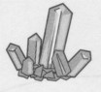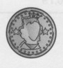

|  |  |
| --- | --- |
|  |  |
| What is the coin made of? ________________ | What did you find? _______________________ |

You find a ring with a mass of 107 There is a block on your desk that

g. You fill a graduated cylinder up acts as a paperweight. Its

with 10 mL of water and put the measurements are 3 cm by 4 cm

ring into the cylinder. The water by 6 cm. The block has a mass of rises up to the 15 mL mark. 184.32 g.

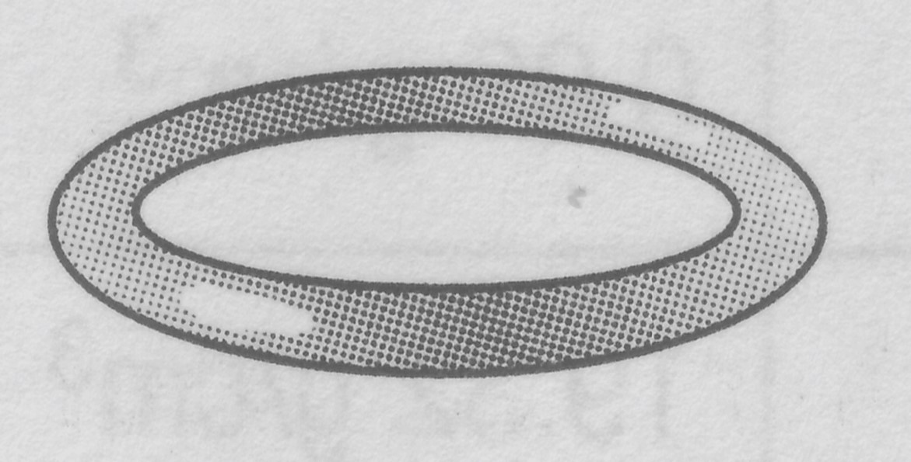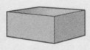

|  |  |
| --- | --- |
|  |  |
| What is the ring made of? _______________ | What is the block made of? _________________ |

**Physical and Chemical Properties:**

Physical Properties -­‐ ____________________________________________________________________

_____________________________________________________________________________________

_____________________________________________________________________________________

Chemical Properties -­‐ ___________________________________________________________________

_____________________________________________________________________________________

_____________________________________________________________________________________

|  |  |  |  |
| --- | --- | --- | --- |
| **Physical Property Characteristics** | | **Chemical Property Characteristics** | |
| Example | Image/Drawing | Example | Image/Drawing |
| Color |  | Flammability (burns) |  |
| Melting  Freezing  Boiling  Condensation  Evaporation |  | Reactivity (ability to combine or react) |  |
| Density |  | Rusting |  |
| Solubility (dissolves in water) |  | Gas Produced/Fizzing |  |
| Hardness/Texture |  | Tarnishing |  |
| Luster |  | Color/Odor Change |  |
| State of Matter/Phase  Change |  | Precipitate Forms (a solid) |  |

Decide whether the following is an example of a physical or chemical change. Provide evidence for your decision.

1. A copper pot turned green when exposed to the environment. _____________________________

______________________________________________________________________________

______________________________________________________________________________

1. Diamonds are a very hard substance that can cut through glass. ___________________________

______________________________________________________________________________

______________________________________________________________________________

1. Sodium reacts very easily with other elements. ________________________________________

______________________________________________________________________________

______________________________________________________________________________

1. Barium melts at 7250 C. ___________________________________________________________

______________________________________________________________________________

1. Iron reacts with oxygen and forms rust. ______________________________________________

______________________________________________________________________________

______________________________________________________________________________

1. The boiling point of water is 1000 C. ________________________________________________

______________________________________________________________________________

______________________________________________________________________________

1. Acid in tomato sauce can corrode aluminum foil. ______________________________________ ______________________________________________________________________________

______________________________________________________________________________

1. A bar of lead is more easily bent than is a bar of aluminum of the same size. _________________

______________________________________________________________________________ ______________________________________________________________________________

Read each of the following and describe what state of matter or phase of matter the molecules are in.

1. The molecules of a substance are moving rapidly in a container. The molecules do not interact with each other. If the container is opened, the molecules will escape from the container. In what phase of matter are the molecules in the container? ________________________________

1. At the same temperature and pressure, which state of matter has the highest density? ________

1. What must be added to water in order to change state from liquid to a gas? _________________

_______________________________________________________________________________

1. When a substance such as ice melts, its temperature increases. Describe what happens to the arrangement of the water molecules as the temperature increases. ________________________

_______________________________________________________________________________

Complete the following Venn diagram on Physical and Chemical Properties of Matter:



Physical Properties



Chemical

Properties